**A Sentimental Analysis of All Six Paramore Studio Albums**

Ally McGinley

Department of Industrial/Organizational Psychology, Montclair State University

PSYC546_01

Dr. Michael Bixter

May 2nd, 2024

**A Sentimental Analysis of All Six Paramore Studio Albums**

My project entails web-scrapping lyrics from every song from Paramore’s six studio albums. Formed in 2004, Paramore is an American pop-punk band known for influencing the “scene music” phase in the 2000s. I will perform a few sentimental analyses to examine the frequency of positive and negative words in each album.

**Importing**

I uploaded the following libraries to my script to ensure the execution of all coding tasks: the tidyverse, rvest, stringr, tidytext, dplyr, ggplot2, and wordcloud. In case websites were updated and URLs changed, I used the function write.csv to ensure all content in my data frame, tidy_albums, would be saved. Paramore’s first five albums, *All We Know is Falling, Riot, Brand New Eyes, Paramore, and After Laughter* were imported from songmeanings.com using html code. The SelectorGadget was used to extract the node “.lyric-box” for each song from Paramore’s first five albums. Paramore’s more recent album, *This is Why*, was imported from genius.com and was extracted by the node “.kUgSbL.”

**Tidy**

After looking at the text I just scrapped, I noticed errors that would skew my analyses. Every lyric from the website songmeaning.com contained the following errors: phrases “\t, \n, and sometimes \r” scattered across the text, words combining despite capitalization, and the phrase “Edit Lyrics” appearing at the end of each text. From each song from Paramores’s first five albums, I had to use the gsub function to remove unnecessary characters and phrases and input spaces between words to ensure a proper word count for future analyses. However, some songs required additional cleaning. The line print(head(pText)) serves to show all text before revisions were made.

**All We Know is Falling**

*All We Know* - For this track, I removed single quotation marks because there was no white space to separate the words that came before and after the quotation mark. I inputted one white space after the question mark to separate sentences. *Pressure* - I removed single quotation marks due to no white space separating words from different clauses. *Emergency* – I removed single quotation marks and added white space after question marks. Despite running a function that separates lowercase capital letters from uppercase letters, I had to run an additional line that separates the phrase “wrongCause” to “wrong Cause.” *Brighter* – I added one white space after the character “)” to ensure the separation of words. *Here We Go Again* and *Never Let This Go* - I added one white space after the character “)”. *Whoa* – I removed single quotation marks and added a space after the character “-“. I separated the phrase “wrongCause” to “wrong Cause.” *Conspiracy* – I removed single quotation marks. *Franklin* – I removed single quotation marks and added one white space after quotation marks. *My Heart* – I added one space before the character “(“ and added one space after the character “)” to ensure the separation of words.

**Riot**

*For A Pessimist I’m Pretty Optimistic* and *That’s What You Get* – I added a space after quotation marks. *Hallelujah* – I removed all punctuation in the text to get rid of the escape character “\”. *Misery Business* – I removed single quotation marks and added one space after the character “!”. I added a space between “goodCause” to make it appear “good Cause.” *When it Rains* – I added one space after question marks and after the character “)”. *Let the Flames Begin* – I added one space after the character “)”. *Miracle* – I added one space after the character “)” and removed single quotation marks. I created 3 functions to separate words that were combined. *Crushcrushcrush –* I added a space after the character “)” and removed single quotation marks. *We Are Broken* – I added one space after the characters “?” and “)” and removed one space before the character “(“. *Fences* - I removed the single quotation mark from the phrase “wide Cause.” *Born For This* – I added one space after the characters “?” and “)”.

**Brand New Eyes**

*Ignorance* – I added one space after the characters “?” and “)” and removed the single quotation mark to form the phrase “fault Cause.” *Playing God* – I added one space after the characters “?” and “)” and added one space before the character “(“. *Brick by Boring Brick* – I added one space after the character “)” and removed the character “\” from two phrases. *Turn it Off* – I added one space after the character “)”. *Feeling Sorry* – I added one space after quotation marks and separated the phrase “IWon’t” into two words. *Looking Up* – I added one space after quotation marks. *Misguided Ghosts* – I added one space after a comma in the phrase “classify,Our.” *All I Wanted* – I removed the character “-“ from the phrase “black and white” and added one space after the character “)”. *Decode* – I added one space after quotation marks and the character “)” and added one space before the character “(“.

**Paramore**

*Grow Up* – I added one space after the character “)” and one space before the character “(“. *Daydreaming* – I added one space after the character “)”. *Interlude Moving On* – I removed single quotation marks. *Aint it Fun* – I added one space after the characters “?” and “)” and removed single quotation marks. I added one space between the phrase “mamaCause.” *Part II* – I added one space after the character “)” and one space before the character “(“. *Still Into You* – I added one space after the character “)” and removed single quotation marks. *Ankliebiters* – I added one space after the characters “?” and “)”. *Interlude Holiday* – I separated the phrase “IRead” into two words. *Proof* – I added one space after quotation marks and removed the single quotation mark in the phrase “arms’Cause.” *Hate to See Your Heart Break* – I added a space after the comma in the phrase “blind,Expecting” and added one space after quotation marks. *One of Those Crazy* Girls – I added one space after quotation marks and removed the character “-“ from a phase. *Be Alone* – I added one space after quotation marks.

**After Laughter**

*Hard Times* – I added one space after the character “)” and one space before the character “(“. *Rose Colored Boy* – I removed all punctuation to remove the character “\” from the text. *Told You So* – I added one spaced after the characters “?” and “)” and one space before the character “(“. Forgiveness – I added one space after the character “)” and before the character “(“. *Fake Happy, Twenty-Six,* and *Pool* – I added one space after quotation marks. *Grudges* – I added one space after quotation marks and removed single quotation marks. *Idle Worship* – I added one space after quotation marks. *No Friend* – I removed the character “:” from the phrase “clear:you.” *Tell Me How* – I added one space after quotation marks and removed single quotation marks.

**This is Why**

I created an object called “remove_phrase1” that would remove the following phrases: “[Verse 1]”,” [Chorus]”, “[Verse 2]”, and “[Pre-Chorus].” This object was applied to all songs in the *This is Why* album. I used the gsub function to ensure there is one space between lowercase and uppercase letters.

*This is Why* and *Running Out of Time* – I added one space after the character “)”. *Big Man Little Dignity* and *You First* – I added one space after all quotation marks. *Figure Eight* – I added one space after the character “)” and removed one space before the character “(“. I removed single quotation marks. *Crave* – I separated the phrase “IJust” into two words and removed the character “\” from the phrase “say, Live in the present I’m already.” *Think Skull* – I removed the phrases “[Intro\\]” and “[Verse\\]” from the text.

**Transform**

I created a data frame named “Albums,” which contains 3 columns. The song column represents the titles of all songs, the album column represents what album the song came from, and the lyrics column has all the lyrics of each song. I then created an object called “orginal_albums” that groups the data frame Albums by the column, Album. I then created an object named “tidy_albums1” to reformat the data to be in a “one-token-per-row” format. I removed stop words from tidy_album1 and renamed my final data frame to tidy_albums.

**Visualize**

To conduct a sentimental analysis on the tidy_albums data frame, I inner joined the “bing” lexicon by each word of the data frame. My first visualization is a word cloud of the top 60 most frequent words to occur in all Paramore lyrics.

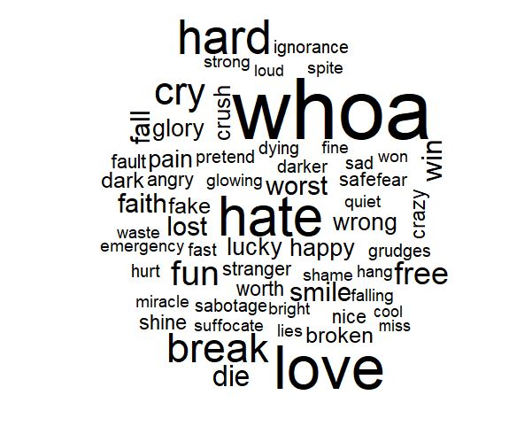

**Figure 1**

*Wordcloud of the Top 60 Most Frequent Words in Paramore Lyrics*

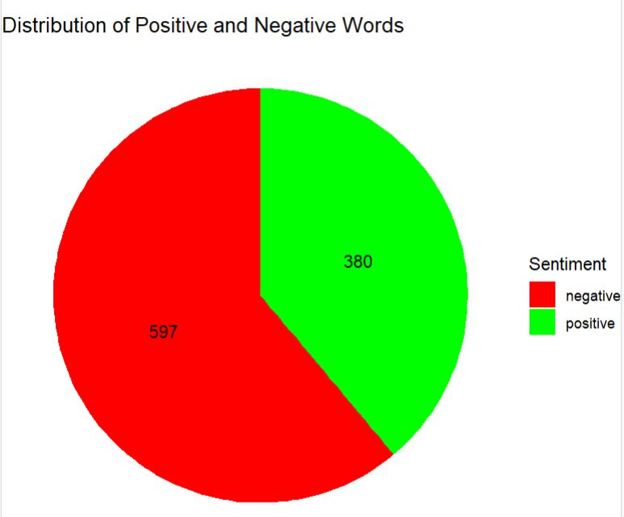

**Figure 2**

*Pie chart of the Distribution of Positive and Negative Words in Paramore’s Lyrics*

My second visualization is a pie chart of the distribution of positive and negative words in Paramore’s lyrics. My third visualization is a bar graph that represents the number of positive and negative words in each album. I created a new object called “album_sentiment_freq” that contains three columns: album, sentiment, and n (the count of occurrences for positive and negative words). I created a new data frame named “Album_Sent_Freq” that contains three columns: “Album” which titles each of Paramore 6 albums, “Total_Positive” and “Total_Negative” which lists the frequency of each positive and negative word by album.

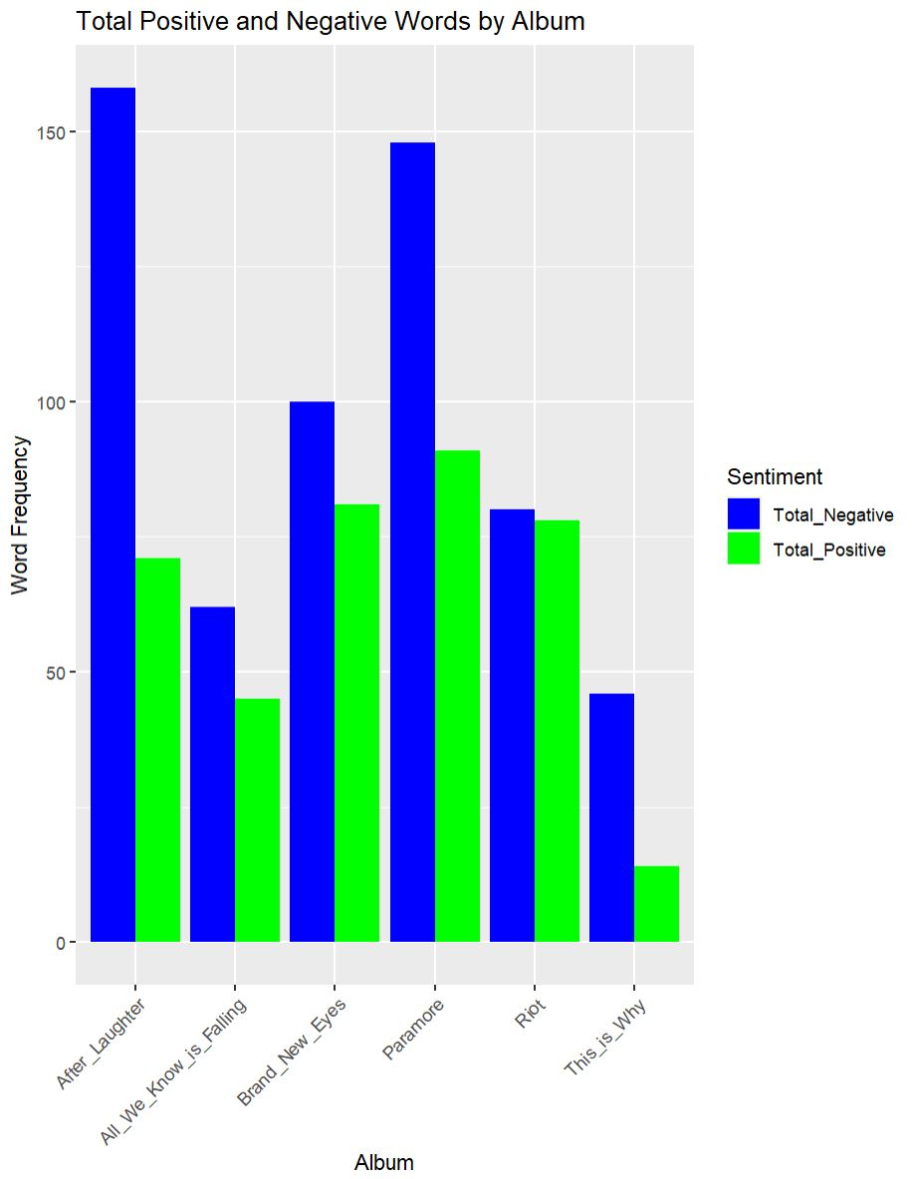

**Figure 3**

*Total Positive and Negative Words by each Paramore Album*

**Conclusion**

According to Figure 1, the top 5 most frequent words in Paramore discography are whoa, love, hate, hard, and break. I came to this conclusion by looking at what words appeared to be the biggest font in Figure 1. Whoa is the most frequent word since it appears frequently in the track *Woah*, from Paramore’s first studio album. According to Figure 2, there are 380 positive and 597 negative words in all Paramore lyrics (not including stop words). This was no surprise since Paramore is known to be an “emo” band – meaning their music is characterized by emotional lyrics. From Figure 3, the album *After Laughter* has the most negative words while the album *Paramore* has the most positive words. *After Laughter* having the most negative words is no surprise since its lyrics contain depressing and dark content. The *Paramore* album has the most positive words due to the album having the most tracks. It is interesting to note that the album *Riot* has almost an equal number of positive and negative words despite being the heaviest rock album Paramore has produced.

**References**

*Paramore Lyrics, Songs, Albums*. SongMeanings. (n.d.).

<https://songmeanings.com/artist/view/songs/137438966864/>

*Paramore*. Genius. (n.d.). <https://genius.com/artists/Paramore>

**Appendix**

**Figure 1**

*Wordcloud of the Top 60 Most Frequent Words in Paramore Lyrics*

**Figure 2**

*Pie chart of the Distribution of Positive and Negative Words in Paramore’s Lyrics*

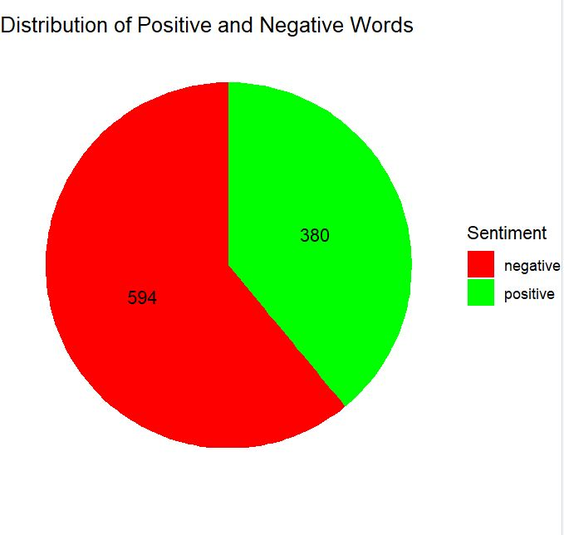

**Figure 3**

*Total Positive and Negative Words by each Paramore Album*

